**RAJALAKSHMI ENGINEERING COLLEGE**

**RAJALAKSHMI NAGAR, THANDALAM – 602 105**



|  |
| --- |
| **CS23A34**  **USER INTERFACE AND DESIGN LAB** |
| **Laboratory Observation NoteBook** |

|  |
| --- |
| **Name :** L K Sudharshan Krishnaa  **Year/Branch/Section :** II/CSE/D  **Register No. :** 230701350  **Semester :** IV  **Academic Year:** 2024-25 |

**Ex. No. : 1 Date : 25.01.2025**

**Register No. : 230701350 Name : L K Sudharshan Krishnaa**



**Introduction to Figma (GOOD and BAD Design)**

**Aim:**

To use Figma to create a simple mobile app login screen, including basic design and prototyping.

**Procedure:**

**Step 1: Sign Up and Create a New Project**

1. Go to figma.com and create an account (if you haven’t already).

2. Once logged in, click “New File” to start a blank project.

**Step 2: Create the Frame (Artboard)**

1. On the left toolbar, select the “Frame” tool (shortcut: F).

2. Choose a mobile preset (e.g., iPhone 13) from the right-hand panel.

**Step 3: Design the Login Screen**

**Add a Background Color:**

1. Select the frame and go to the right-side panel.

2. Under “Fill” choose a background color (e.g., light blue #E3F2FD).

**Insert a Logo:**

1. Click the “Rectangle” tool (shortcut: R) and draw a placeholder for a logo.

2. Use the “Text” tool (shortcut: T) to add your app name, e.g., “MyApp”.

3. Adjust font size and color from the right-hand panel.

**Add Input Fields:**

1. Use the “Rectangle” tool to draw two boxes for username and password fields.

2. Add placeholder text inside (e.g., “Enter your email”).

3. Apply rounded corners under “Corner Radius” in the right panel.

**Add a Login Button:**

1. Create a button using the Rectangle tool and set the color to blue (#1E88E5).

2. Use the Text tool to add the text Login inside the button.

**Align Elements:**

Use the alignment tools in the top menu (center everything vertically and

horizontally).

Adjust spacing between elements using the Auto Layout feature (Shift + A).

**Step 4: Prototyping the Interaction**

1. Click the Prototype tab on the right panel.

2. Select the Login button and drag the blue dot to a new frame (e.g., a home

screen).

3. Set the interaction to On Click → Navigate to the next screen.

4. Choose an animation effect (e.g., Smart Animate).

**Step 5: Preview the Design**

1. Click the Play button in the top-right corner to preview your app prototype.

2. Try clicking on the login button to see the transition to the next screen.

**Step 6: Export Assets**

1. Select the elements you want to export (e.g., the logo or button).

2. In the right-hand panel, click &quot;Export&quot; and choose a format (PNG, JPG, SVG).

3. Click “Export” to download assets for developers.

#### **Figma Website Overview**

● Figma’s official website ([figma.com](https://www.figma.com/)) serves as a platform for accessing its cloud-based design tool, learning resources, community plugins, and collaboration features.

● It provides solutions for UI/UX design, prototyping, and design systems while offering seamless real-time collaboration for teams.

● Figma includes various built-in tools to streamline the design process.

Figma’s cloud-based accessibility, powerful tools, and collaboration features make it a preferred choice for designers, developers, and businesses worldwide.

**Bad Design:**

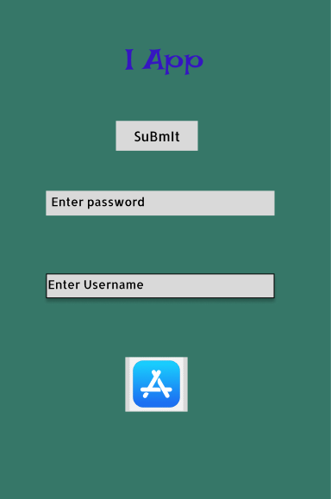

**Fig : Bad Design**

This login page has a poor design due to several issues:

1. Inconsistent Font & Capitalization – The title and button text use inconsistent capitalization and an unprofessional font.

2. Misaligned Elements – The username and password fields are not properly aligned, making the layout look unstructured.

3. Poor Color Choices – The background color is dull and unappealing, reducing readability and visual appeal.

4. Random Image Placement – The icon appears unrelated and misplaced, adding to the clutter.

**Good Design:**

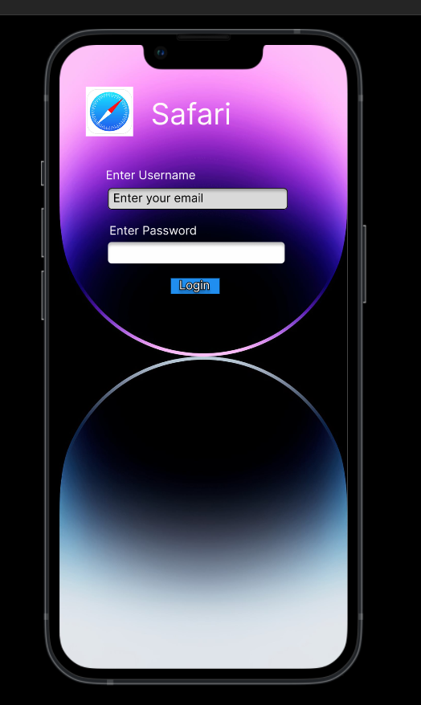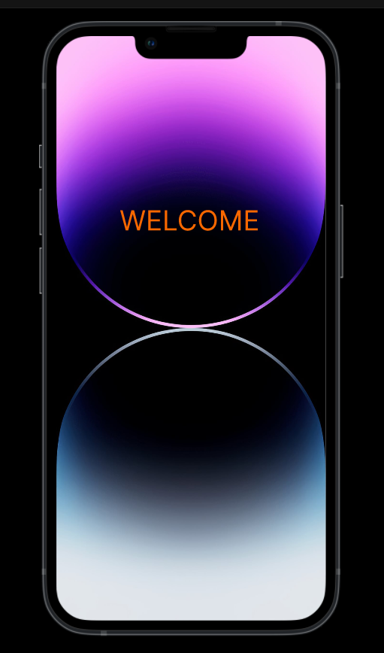

**Fig : Good Design**

1. Aesthetic Visual Appeal  
   * The gradient background and circular reflections create a modern and elegant design. The use of colors (purple, black, and blue gradient) adds a sleek and futuristic touch.
2. Minimalistic and Clean Layout  
   * The login screen follows a minimalistic approach, avoiding unnecessary elements. The form fields and login button are clearly visible without distractions.
3. Clear Visual Hierarchy  
   * The title "Safari" and the input fields are well-aligned and easy to read. On the welcome screen, the bold "WELCOME" text immediately grabs attention.
4. Smooth Transition Experience  
   * The second screen provides an immediate and simple confirmation (WELCOME message), making the user feel acknowledged after logging in. The consistency in design elements maintains a seamless transition.

**Result:**

Hence the introduction to figma with good and bad design has been successfully studied and executed.